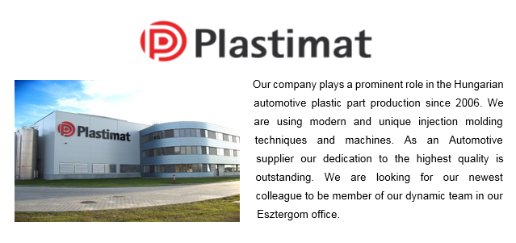
Process Engineer

RESPONSIBILITIES:
- Responsible for manufacturing process, creating associated documentations (working instructions per quality standards, revise drawing, accurate instructions and workmanship standards and process procedures
- Creating flowcharts, technical instructions (Control Plan), participating in the creating process of manufacturing documents and processes (FMEA)
- Lead the implementation of manufacturing processes including, but not limited to: facilities, layout, equipment selection and installation, work flow, process flow, process characterization, process monitoring/control methods, material handling, tool selection, consumables, documentation, training, support, and equipment service/maintenance
- Identify ways to reduce production costs through recommendations – i.e. new process equipment, equipment, assist with equipment selection and drive implementation of new equipment.
- Introduction of new product technology, continuous improvement
- Preparation, monitoring and evaluation of product trials
- Preparation and maintenance of regulations, standards
- Lead process improvements while mentoring others to improve
- Train and supervise staff on new development processes and technology
- Characterize, verify, and validate manufacturing processes to meet various regulatory requirements

requirements:
- Engineering ( mechanical or Electrical ) degree
- Minimum of 3 years’ experience in a manufacturing environment required with preference to the automotive industry
- Solid knowledge of APQP, FMEA, IATF 16949, ISO 14001
- Fluent English both verbally and in writing.

WHAT WE OFFER:
- International, stable manufactory background in Automotive industry
- Exciting and challenging projects
- Employee-friendly environment, dynamic team
- Competitive salary

PLACE OF WORK:
- Esztergom (45 km from Budapest)

BE THE MEMBER ONE OF THE LARGEST PLAYERS IN CAR INTERIORS MARKET!
SEND YOUR CV TO US TODAY:
monika.toth@grupoantolin.com

